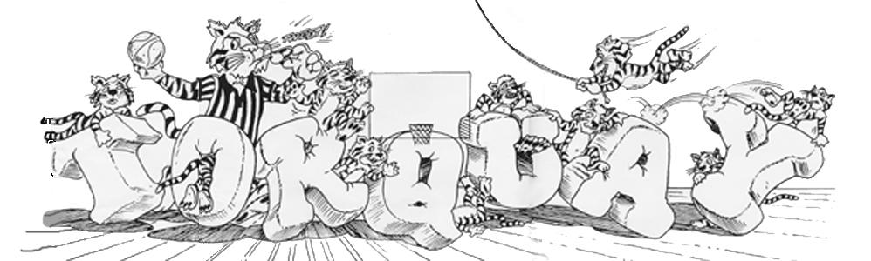

##### getting to know you…

**(Please bring the completed form to your Welcome to Kindergarten Session on May 25, 2017)**

1. Child’s Name:___________________________________________________
2. First name you would like your child to be called: ________________________
3. Names of other children in the home and their ages: _____________________
4. Main language spoken at home:______________________________________
5. Special concerns we should be aware of (allergies, fears, phobias, bathroom problems, medical) ______________________________________________

__________________________________________________________________________________________________________________________

1. Previous experience in group situations with other children (preschool, recreation program, Sunday school) __________________________________________

_____________________________________________________________

1. One of the most unique /special things about my child is: _____________________________________________________________

_____________________________________________________________

1. **Social relationships**: What words would you use to describe your child when interacting with other children? (leader, organizer, bossy, shy etc.) _____________________________________________________________

_____________________________________________________________

1. Does your child already know other children who will be attending Torquay? ____________________________________________________________

_____________________________________________________________

1. Work Habits: What words would you use to describe your child’s work approach? (rushed, meticulous, positive, systematic, follows directions, likes routines).

__________________________________________________________________________________________________________________________

1. What type of quiet activities does your child like / dislike to do? ____________________________________________________________

_____________________________________________________________

1. What do you see as your child’s strengths/things your child does well? __________________________________________________________________________________________________________________________
2. What do you see as your child’s weaknesses? _____________________________________________________________

_____________________________________________________________

1. What is something you would like your child to develop/learn this year? _____________________________________________________________

_____________________________________________________________

**Teacher Notes:**

**________________________________________________________________________________________________________________________________________________________________________________________________________________________________________________________________________________________________________________________________________________________________________**

**____________________________________________________________**